Intrepid Theatre Club
  - Visual Story

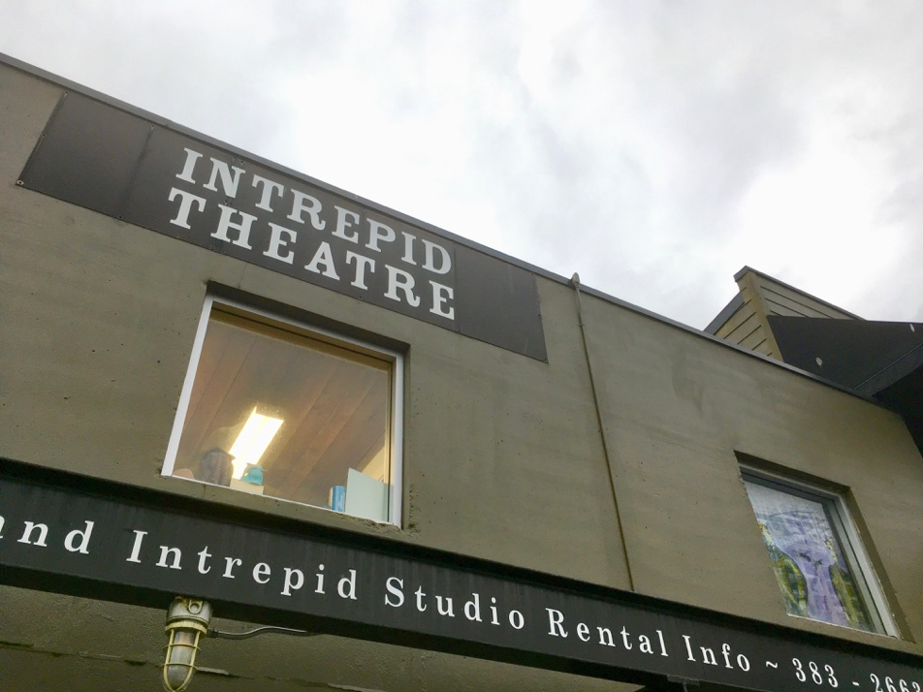

This venue guide is to help you prepare for your visit to Intrepid Theatre Club. It includes information about the theatre’s location, a visual guide to the space, and what you can expect when you come to see a show.

About

Intrepid Theatre Club is a small venue in downtown Victoria, on the traditional and unceded territory of the Lekwungen people. Throughout the year, we use the theatre during three festivals: OUTstages, UNO Fest, and the Fringe Festival.

We also rent the theatre to various companies and groups who do their own shows, including theatre, music performances, comedy, dance, and improv.

Location

Intrepid Theatre Club is located at #2 - 1609 Blanshard Street, Victoria, BC V8W 2J5. It is at the corner of Fisgard Street, across from Romeo’s pizza.

Click this link to view on Google Maps.

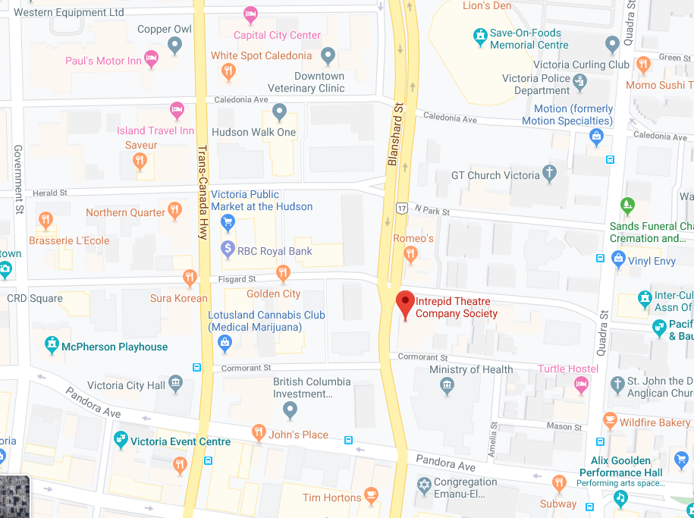

Parking

If you are coming to a show at Intrepid Theatre in the evening, you can park for free in the parking lot. Some of the other businesses in this lot are Serious Coffee, the Liquor Plus offices, and Thomas & Birch Kitchen and Bath. There is a designated accessible parking spot in front of Serious Coffee.

Here is a picture of the parking lot, taken from the corner of Blanshard and Fisgard St.

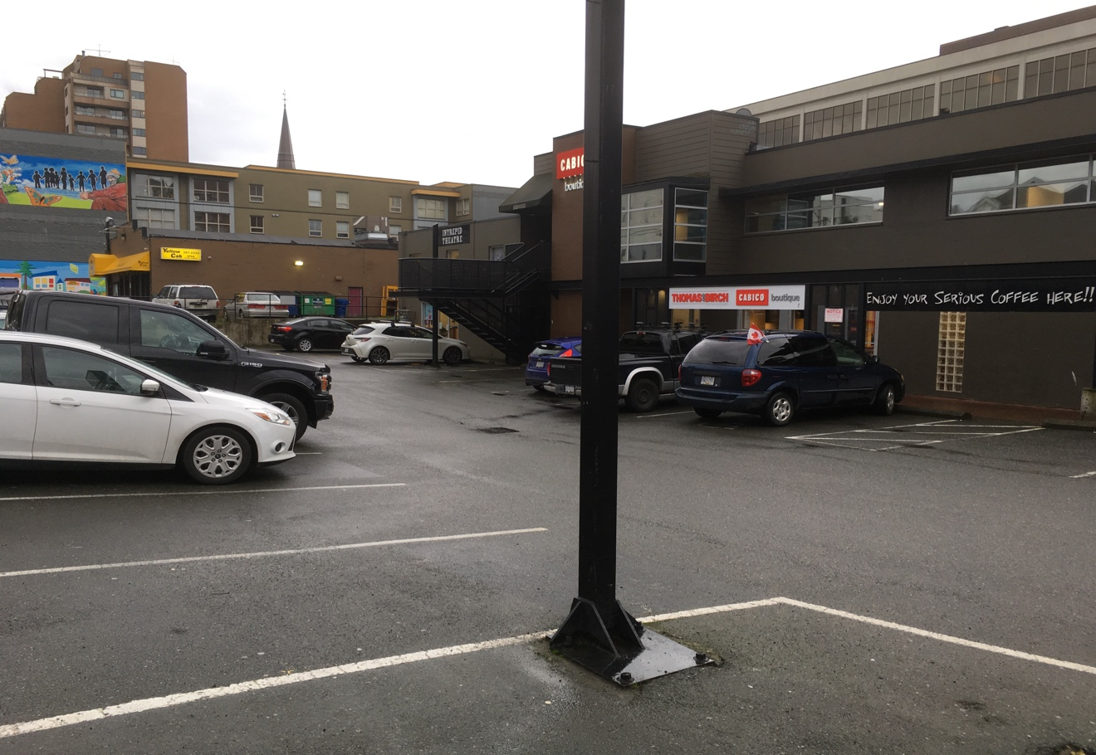

There is street parking along Fisgard Street.

The nearest parkade is the Centennial Square Parkade, two blocks away (entrance at 645 Fisgard St).

Transit

Some of the BC transit bus routes that run near Intrepid Theatre are:
#6 along Quadra St.
#2, 27 & 28 along Pandora Ave.
#4, 11, 30, 31, 50, 70, and others along Douglas St.

Cycling

There are protected bike lanes along Pandora Ave., two blocks away from Intrepid Theatre. It can be busy to bike along Blanshard, Douglas, or Quadra St., and there are no bike lanes, but you can always walk your bike on the sidewalk. Except during the Fringe Festival, there are no bike racks in the Intrepid Theatre parking lot. You can lock your bike to the fence between Intrepid Theatre and Yellow Cab (next door), or on the sign poles along Fisgard St.

When You Arrive

This is what Intrepid Theatre Club looks like from outside.
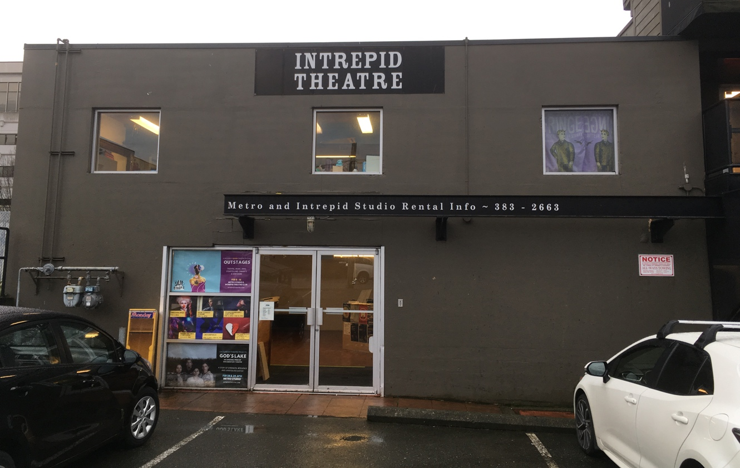

When you are coming from outside, both doors open toward you (pull to open). There is no automatic push button. The entrance is level to the ground and wheelchair accessible, though there is a small metal lip.

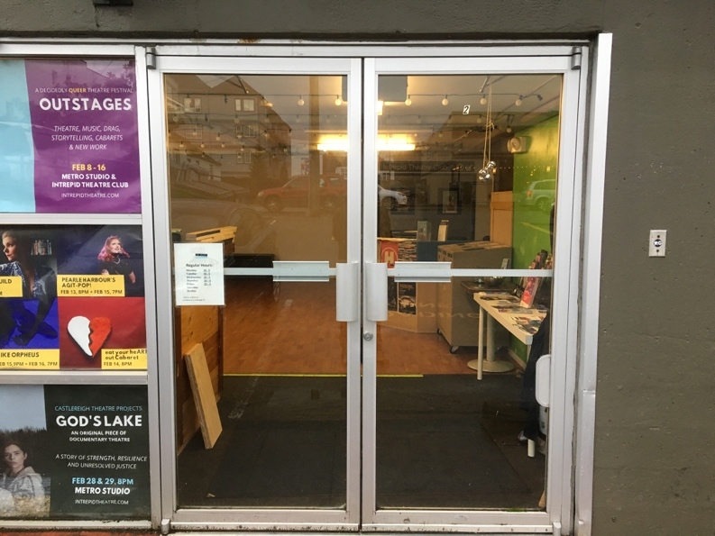

The Lobby

Once you enter, you will be in the lobby. If the theatre is not open yet, you’ll wait in the lobby until it’s time to go in. The lobby can get busy if there are lots of people. There are chairs and benches if you want to sit down.

In this photo, the daytime fluorescent lights are on, but in the evening the incandescent bulbs that you can see in this photo will usually be on instead. Their lighting is softer and dimmer.

The doors to the theatre are across the lobby.

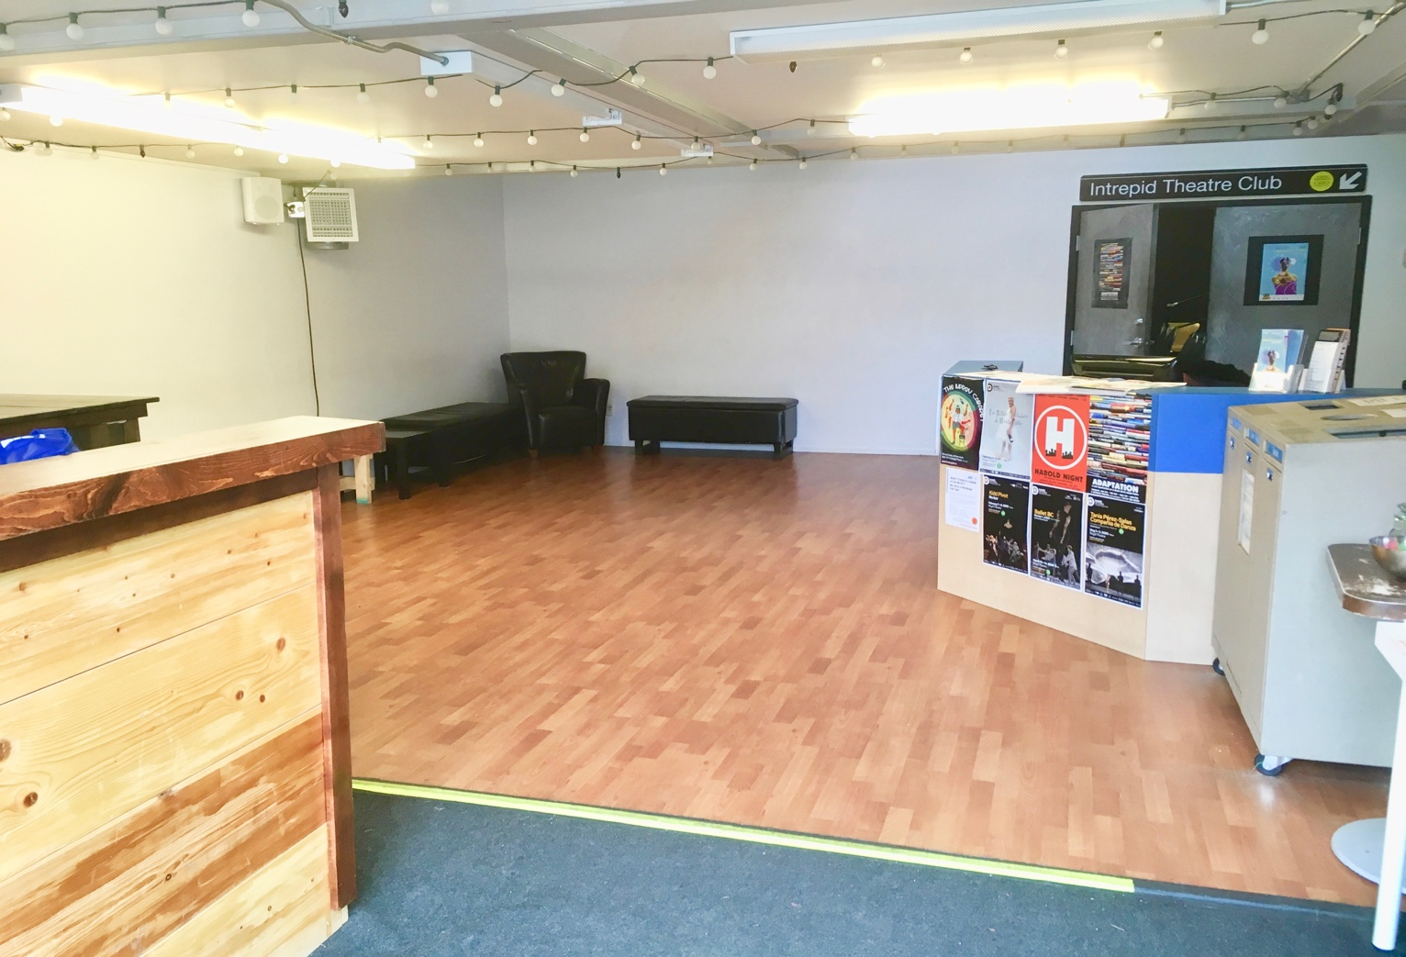

Box Office

If you are here for a show that is part of OUTstages or UNO Fest, there will be a box office table set up to the left of the doors. This is where you buy a ticket, or check in and give your name if you’ve
already booked your ticket.

We have several accessible ticket programs. This includes free
tickets for personal support workers for all Intrepid festivals
and presentations, and free youth tickets for some festivals. Check intrepidtheatre.com for details.

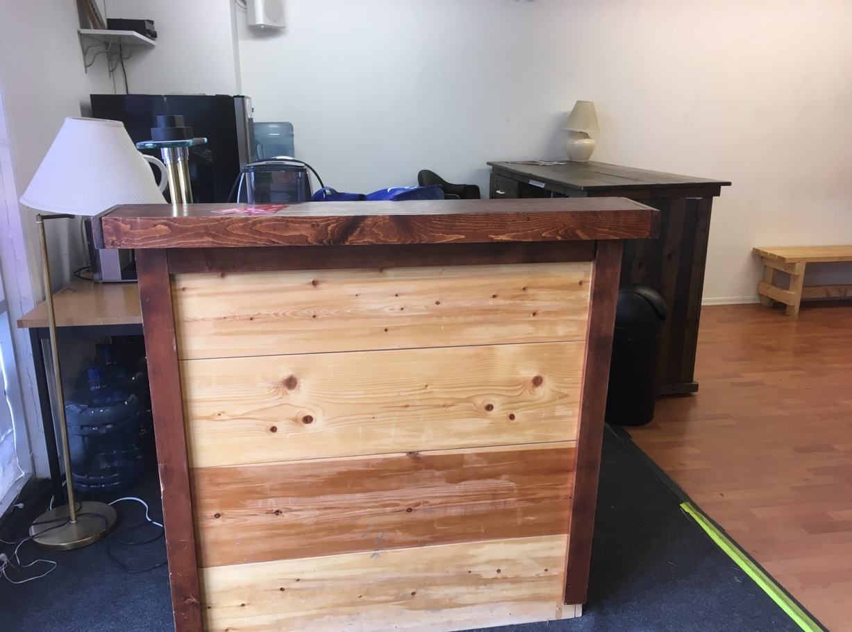

There will be one or two volunteers working at the box office.

There is also a Front-of-House manager who supervises the box office and audience areas. Their job is to help the audience, and they’ll usually be near the front doors when you arrive.

If you need help or have any questions, you can ask the Front-of-House manager.
If you need priority seating, let the Front-of-House manager know when you arrive, and they’ll be happy to take you into the theatre a few minutes before the rest of the audience. They also have information about any effects or content during the show that might be surprising, or that audience members may be sensitive to, such as bright lights, loud sounds, or haze.

Concession

Some shows have a bar or concession, usually set up near the box office.

Some items that might be available are soda, water, beer, wine, cider, candy, and snacks. You can usually take your drink inside the theatre.

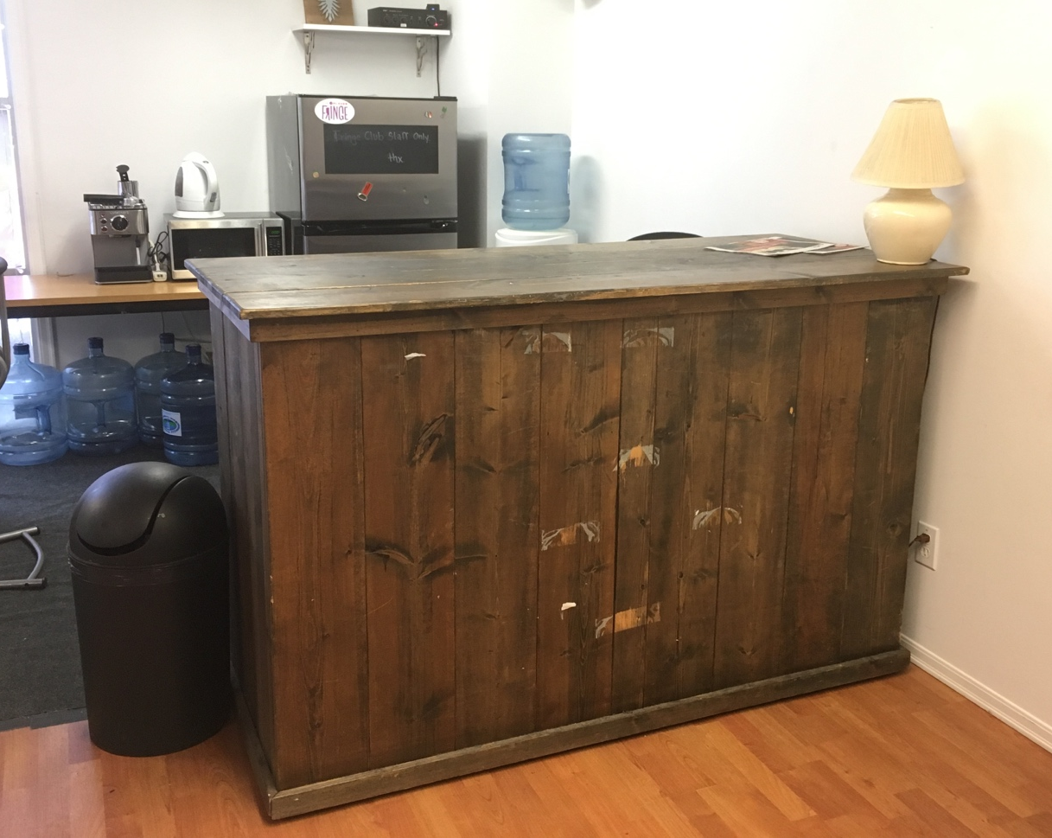

Washrooms

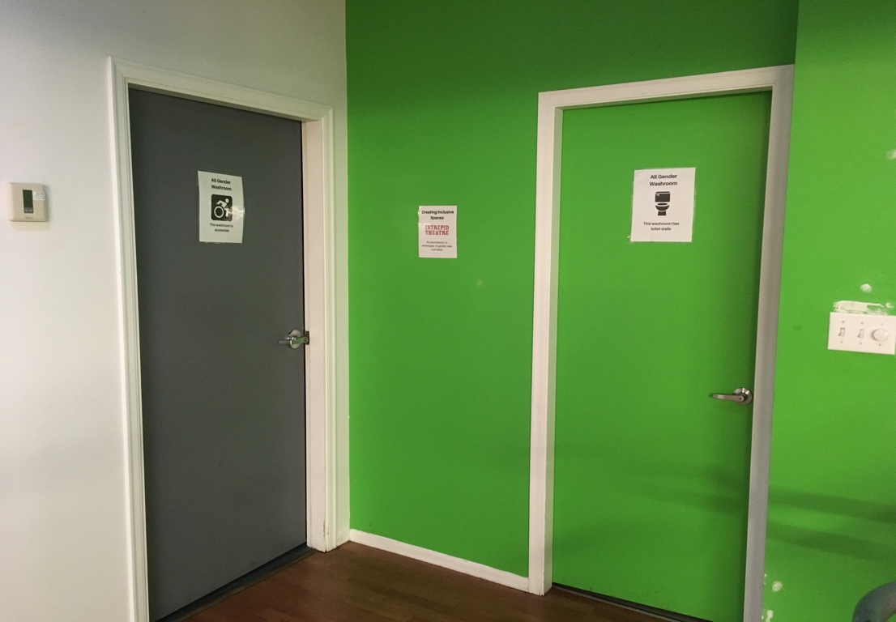

There are two single washrooms in the corner of the lobby.

Washrooms at Intrepid Theatre are all-gender. Intrepid Theatre is committed to gender inclusion and supports people of all genders in choosing the washroom that feels most comfortable.

The washroom on the left is wheelchair accessible and has a grab bar. The washroom on the right is smaller.

To the right of the washrooms is a staircase to the Intrepid Theatre administration offices. This area is closed to the public.

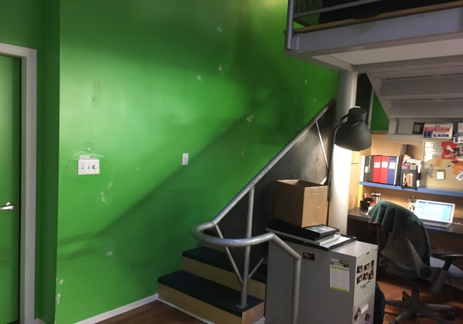

Inside the theatre
For Intrepid Theatre presentations or festivals, the theatre will open about 15 minutes before the show starts.

This is what the theatre entrance looks like when the doors are closed.

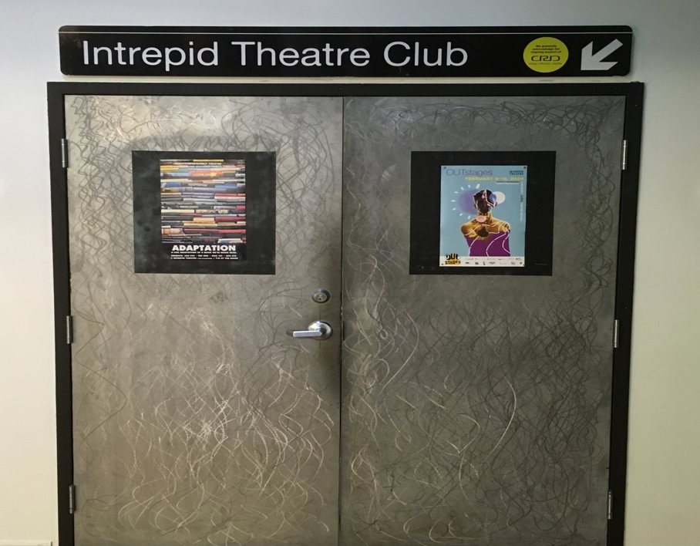

And this is what it looks like with one door open.

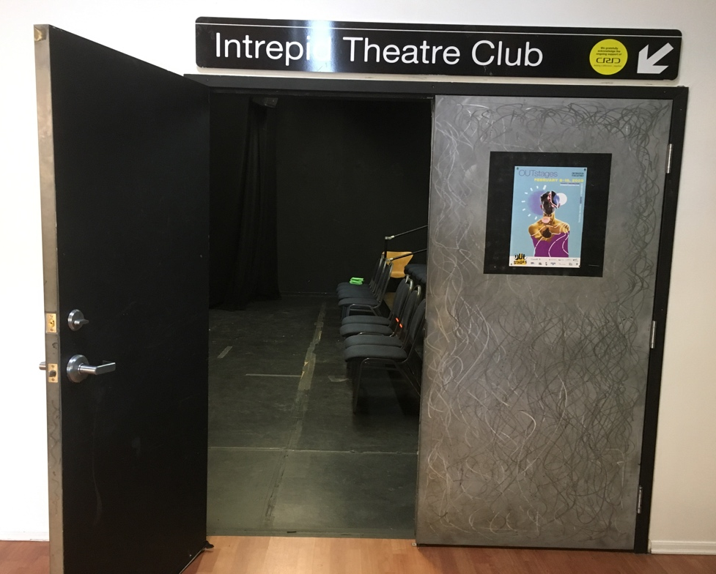

Intrepid is a black box theatre, which means that the space is simple, without many permanent fixtures, so that it can be used for lots of different types of shows and events.

It looks like this when you go inside.

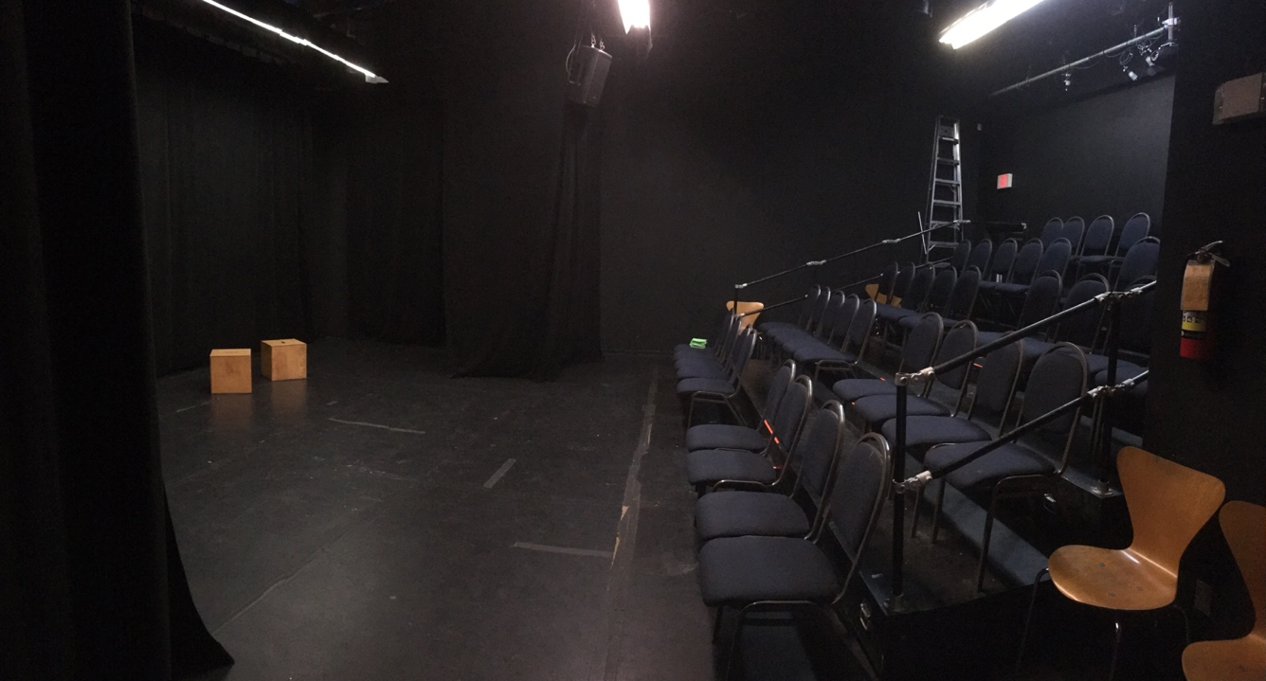

There is a stage area, which may have a set, props, musical instruments, or technical equipment on it. This is what the stage looks like from the audience.

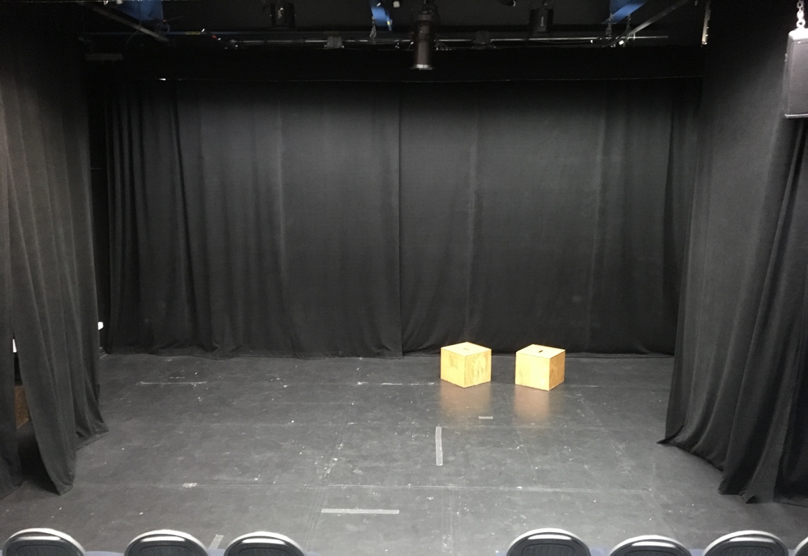

In this photo, the stage is lit with fluorescent lights, but during the show, these won’t be on. The stage lighting is softer and warmer, though there can sometimes be flashes or moments where the lighting is bright. The lighting system has a slight hum, which you may be able to hear in quiet parts of the show.
This is what the audience seating looks like from the stage. It is general seating, which means you can choose whichever seat you like.

There is an emergency exit on the opposite side of theatre from where you came in.

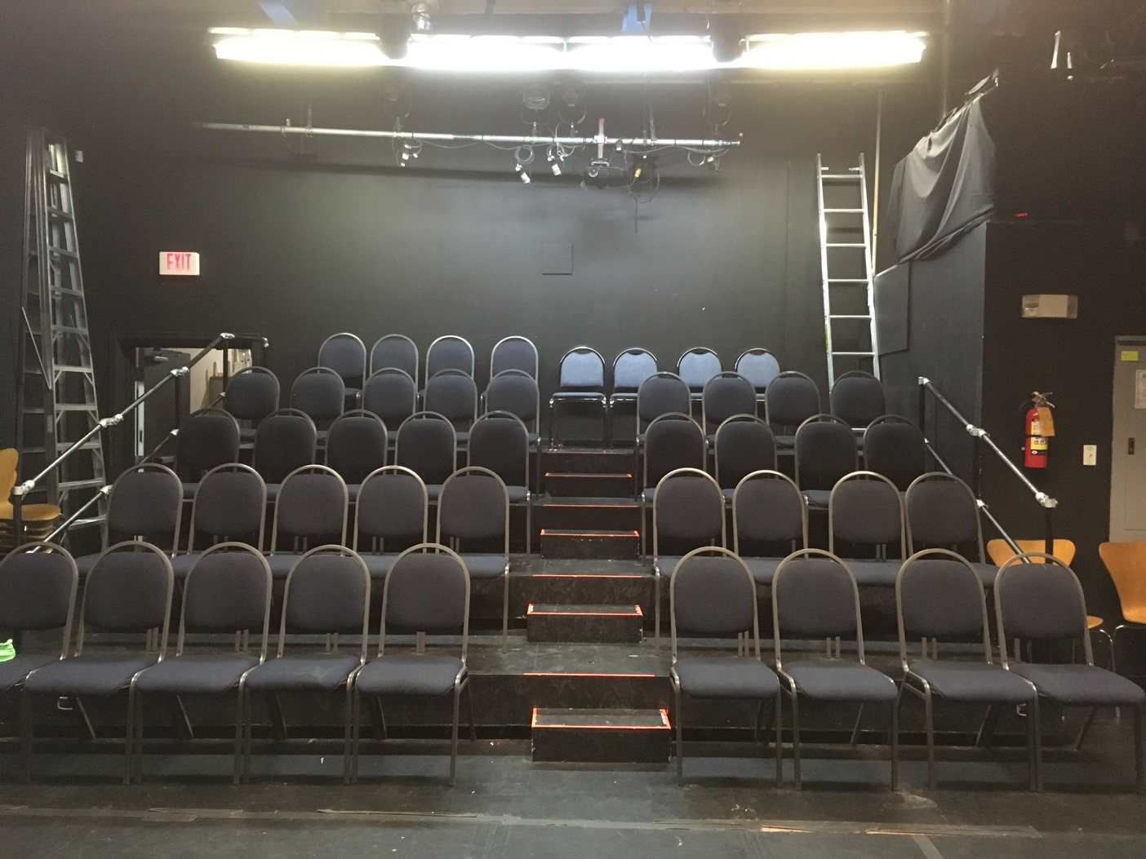

There are 5 rows of chairs. The rows of seats are tiered. There is an aisle with stairs in the centre, and it does not have a railing. The first row of chairs, on the floor level, can be removed for audience members using wheelchairs. The space can fit about 50 seats in total.

If you need to leave during the performance, exit through the same doors you entered through. The picture below is what the doors look like from inside the theatre.
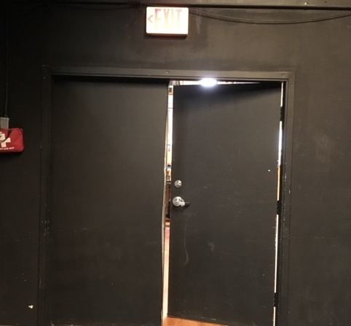

Depending on the show, the Front-of-House manager might ask you to wait until a certain moment to go back in, or you may not be allowed to go back in.

During the show

At the show start time, the Front-of-House manager will usually talk for a few minutes to welcome the audience and give some information about the show. They will mention effects that could be surprising or that audience members might be sensitive to, like haze or strobe lighting, and any content warnings about material in the show that could be triggering or upsetting.

Most Intrepid Theatre presentations and festival performances will start promptly on time. Some shows may allow latecomers, some may allow audiences to come and go throughout the show, and some may not admit latecomers at all—it varies from show to show. See individual show details at intrepidtheatre.com.

During the show, the performers will usually be on the stage, but may be in the audience area too. There could be effects such as haze, strobe lighting, or loud music or sounds. The theatre may get very dark at times.
At the end of the show, people will clap, and might cheer, to show appreciation for the performers. If it is too loud, it’s okay to cover your ears. If you want to show appreciation without clapping, you can wave your hands in the air.

After the show

When the show is over, or if you need to leave early, you will exit the theatre through the same doors you entered through.

If there is an event after the show, like a reception or a meet-and-greet with the artist, it will be in the theatre or the lobby, and there will usually be an announcement to tell you about it.

When you are ready to leave, you will exit through the same lobby doors you entered through. They open away from you (push to open) and you will end up in the parking lot on Fisgard St.
Because many companies and groups use Intrepid Theatre, the procedures and rules will be different for every show, so we can’t tell you exactly what to expect. Some things that might be different, depending on what show or event you’re here for, are:
?

- If there is a box office
- If you can buy tickets at the door
- What time the theatre opens
- If the Front-of-house manager talks to the audience before the show
- If and when latecomers are admitted
- If you can exit the theatre and come back in during the show
- If there is an intermission
- How long the show is
- How many staff or volunteers are present
- If there are signs or an announcement to let you know about haze, strobe lighting, loud music or sounds, or other effects that might be surprising.
However, each show will have someone present who will know the answers to these questions, so you can always ask before the show starts.

Accessibility Info

For information about accessibility measures at Intrepid Theatre festivals and presentations, such as relaxed performances, American Sign Language interpretation, and live audio description, visit our website intrepidtheatre.com.

We hope you enjoy your visit!

If you have any questions, or feedback about your experience at Intrepid Theatre or about this guide, please contact Holly by emailing holly@intrepidtheatre.com or calling 250-383-2663.

