Metro Studio Theatre
  - Visual Story

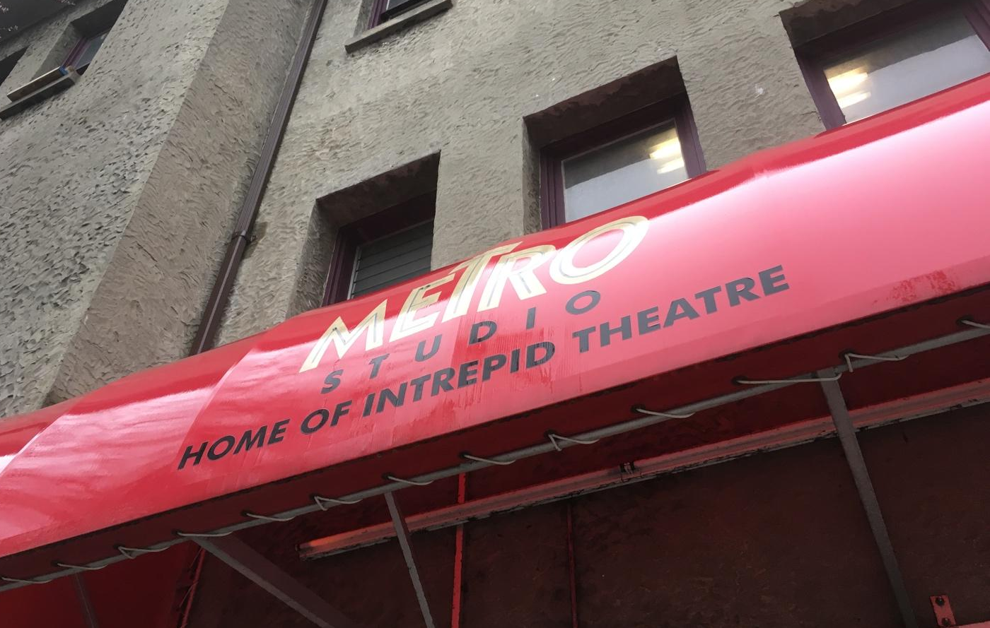
This venue guide is to help you prepare for your visit to the Metro Studio Theatre. It includes information about the theatre’s location, a visual guide to the space, and what you can expect when you come to see a show.

About
The Metro Studio Theatre is in downtown Victoria, on the traditional and unceded territory of the Lekwungen people. Intrepid Theatre runs the Metro Studio, and throughout the year, we use it for our three festivals: OUTstages, UNO Fest, and the Fringe Festival.
We also rent the theatre to various companies and groups who do their own shows, including theatre, comedy, and dance. Sometimes there are other events at the Metro, such as conferences or other gatherings.

Location
The Metro Studio is located at 1411 Quadra Street, Victoria, BC V8W 2L2. It is at the corner of Johnson Street. The Metro Studio is attached to the Victoria Conservatory of Music (VCM).
Click on this link to view on Google Maps.
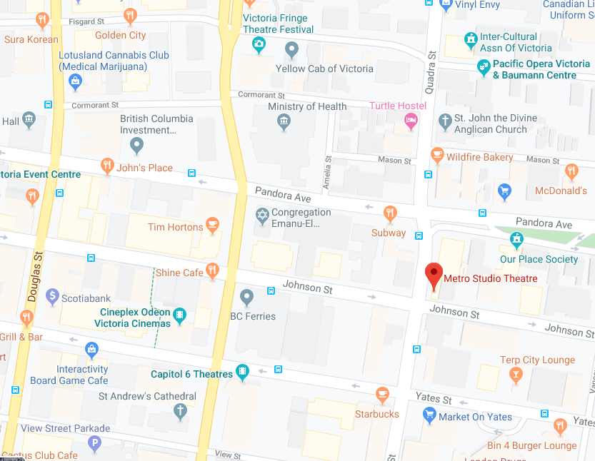

Parking

There is no designated parking for the Metro. (The parking lot behind the Metro is reserved for the Victoria Conservatory of Music.) There is street parking along Johnson Street, which is free after 6pm. The nearest parkade is the Johnson St. Parkade (entrance at 750 Johnson St.). The picture below is taken from across the street, at the corner of Quadra and Johnson.
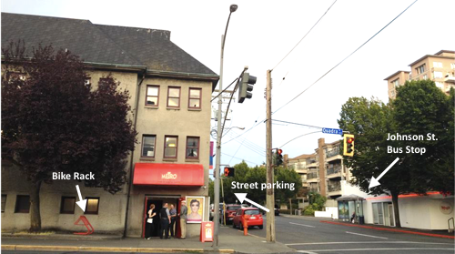

Transit

Some of the BC transit bus routes that run near the Metro are:
#6 along Quadra St.
#2, 24, 25, 27, 28 along Johnson St. (Johnson is a one-way street going away from downtown. In the opposite direction, these routes run on Yates or Pandora.)
Many other routes also stop within walking distance of the Metro along Pandora, Yates, Fort and Douglas Streets.

Cycling
There are protected bike lanes along Pandora Ave., one block away from the Metro. It can be busy to bike along Quadra St., and there is no bike lane, but you can always walk your bike on the sidewalk. There is a bike rack to the left of the Metro Theatre entrance. There are also bike racks around the back of the Metro, near the VCM entrance. (Go up Johnson toward Vancouver St. and they are on the left behind the Metro.)

When you arrive
You will enter from Quadra Street through the red doors in the picture below. There is a red awning above the doors.
When you are coming from outside, the doors open toward you (pull to open). They are quite heavy. There is no automatic push button. The entrance is level to the ground and wheelchair accessible, though there is a small metal lip.

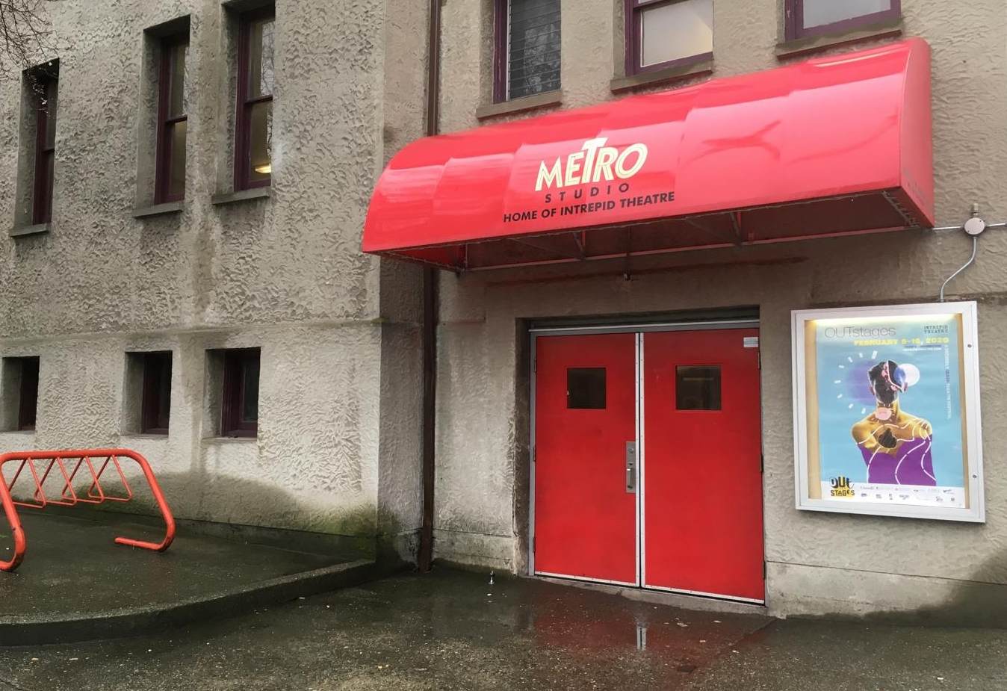
If you are here for the Fringe Festival, the box office tent will be set up beside these doors. There might be line-ups when you arrive. The line going to the left of the box office (along Quadra) is to buy tickets, and the line going to the right of the red doors (up Johnson) is for people who have tickets already and are waiting to go inside.
For any show other than the Fringe, these main doors will open 1 hour before the show.

The Lobby
Once you enter, you will be in the lobby. This is what it looks like.
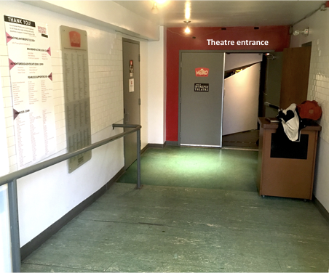
It’s quite small, and is just for passing through. There aren’t any chairs, but the Front-of-House manager can get one if you need one. The lobby can get busy if there are lots of people waiting before the theatre doors open. You can wait outside if you prefer. If it’s a busy show, there may be a line-up along the side of the building outside (on the sidewalk up Johnson Street).
The lobby floor is slightly sloped. There is a handrail on the left side (the right side when leaving the theatre and heading toward the exit).
There is always a Front-of-House manager at the Metro. They are an Intrepid Theatre staff member who supervises the audience areas. Their job is to help the audience, and they’ll usually be in or near the lobby when you arrive. If you need help or have any questions, you can ask the Front-of-House manager.

Box Office

If you are here for a show that is part of OUTstages or UNO Fest, there will be a box office in the lobby on the right-hand side. This is where you buy a ticket, or check in and give your name if you’ve already booked your ticket. The box office opens 30 mins before the show starts, at the same time the front doors open.
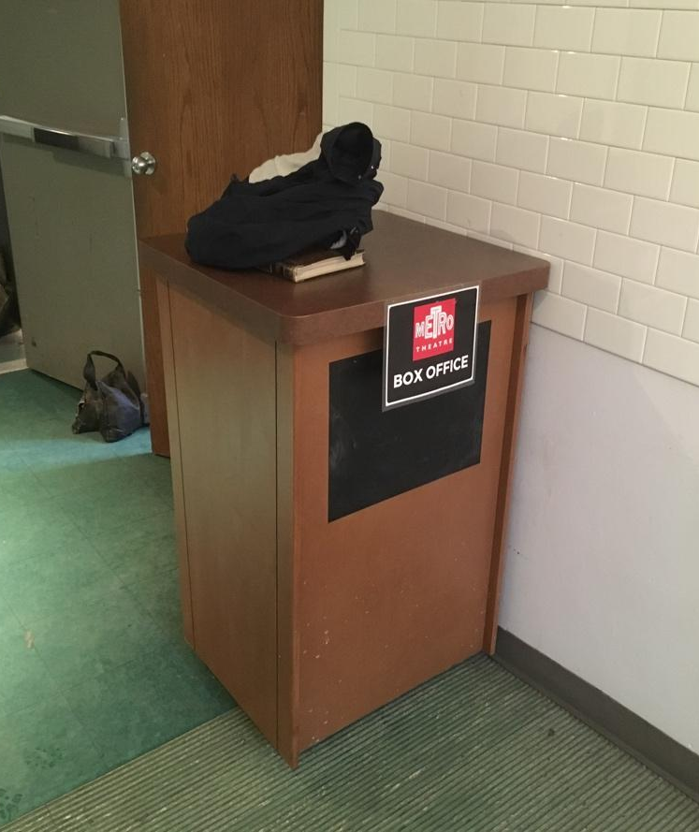
The Box office table FOH Manager: Geoff Malcolm (he/him)

There will be 1-2 volunteers working at the box office and a staff member (pictured above).
We have several accessible ticket programs. This includes free
tickets for Deaf and hard of hearing audience members and for audience members with disabilities, personal support workers for all Intrepid festivals and presentations, and free youth tickets for some festivals. Check intrepidtheatre.com for details.
If you need priority seating, let the Front-of-House manager know when you arrive, and they’ll be happy to take you into the theatre a few minutes before the rest of the audience. (See the ‘Entering the theatre’ section later in this guide for info on when audiences are let into the theatre.) They also have information about any effects or content during the show that might be surprising, or that audience members may be sensitive to, such as bright lights, loud sounds, or haze.

Washrooms

The main washrooms are upstairs. From the entrance to the lobby, you will see stairs on your right. They lead to the washrooms. There are railings on both sides.
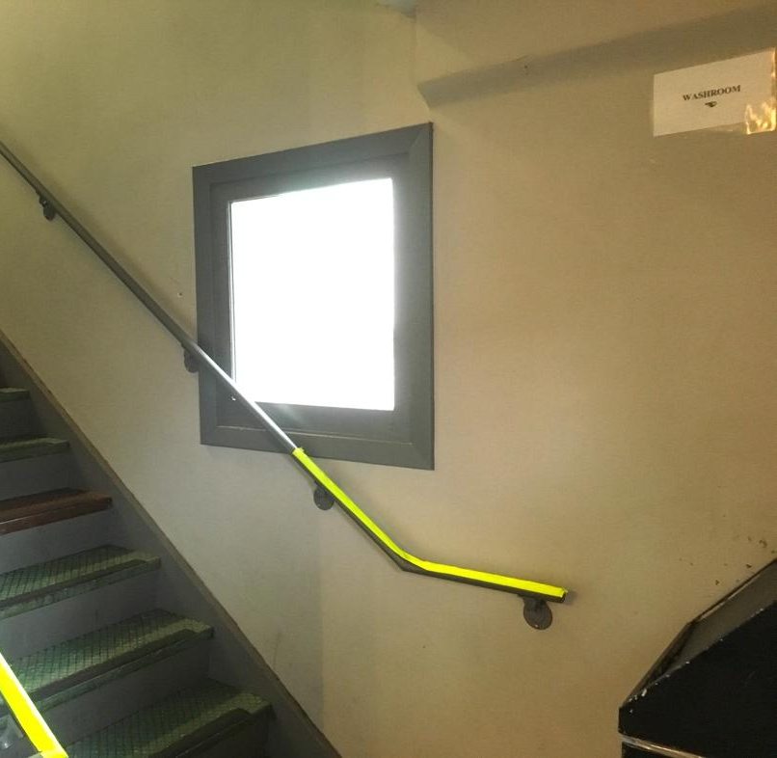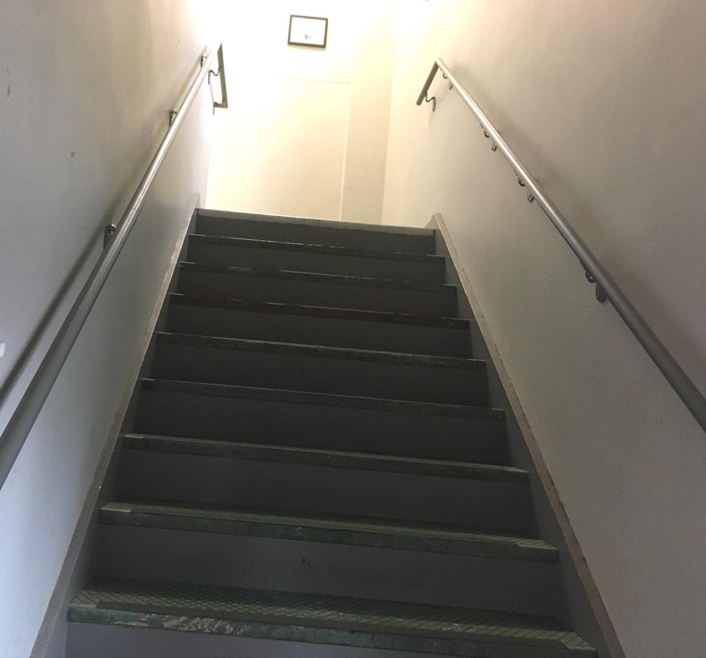

Below is a picture of what it looks like at the top of the stairs. Follow this hall to get to the washrooms. The lights in this hall are fluorescent.
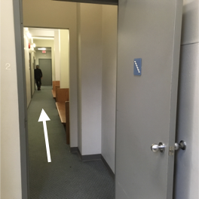

You’re welcome to sit on the benches, just make sure not to leave any garbage or personal items behind. The classrooms along the hall are part of the VCM and will be locked.
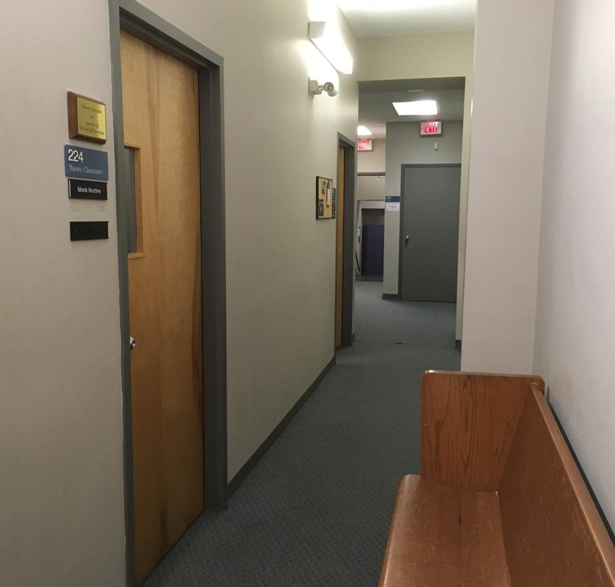
You’ll then arrive at the two washrooms. These are the doors. There is a water fountain and hand sanitizer on the wall between the two washrooms.
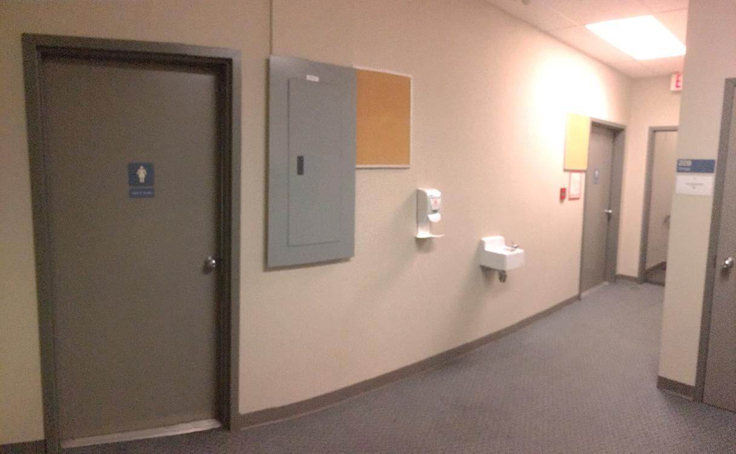
During our festivals—OUTstages, UNO Fest, and Fringe—both washrooms are all-gender. During other shows, they may be designated as women’s and men’s. Intrepid Theatre is committed to gender inclusion and supports people of all genders in choosing the washroom that feels most comfortable. The washroom on the left has two sinks and two stalls. The washroom on the right has two sinks, two urinals, and one stall.

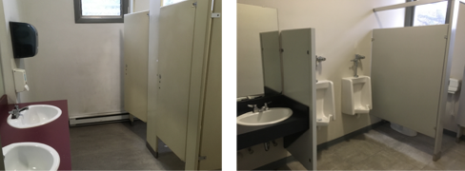

The wheelchair accessible washroom is on the main floor. It is through a door in the lobby to the left of the theatre doors. This door is usually closed because it also leads to backstage. Please let a volunteer or the Front-of-House manager know you need to access the main floor washroom, and they’ll be happy to show you through.

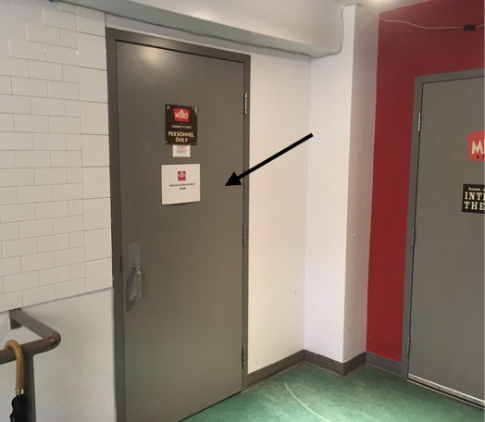

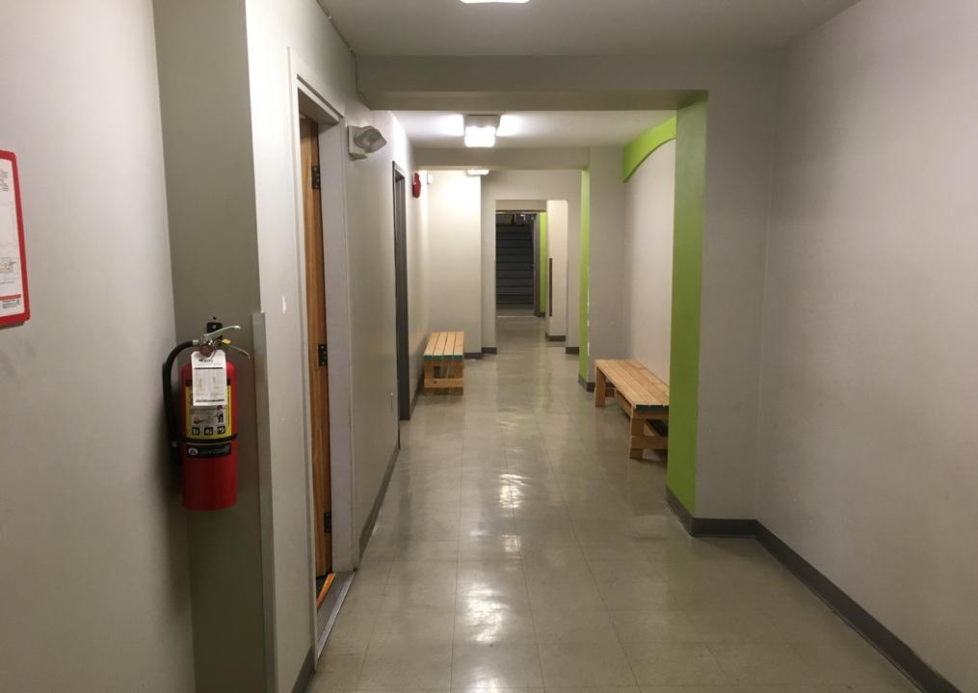
At the end of the hall is a grey door. The washroom is through there. It has one sink, one toilet, and a grab bar.

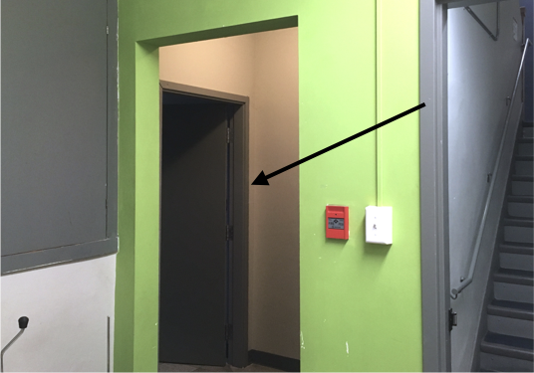

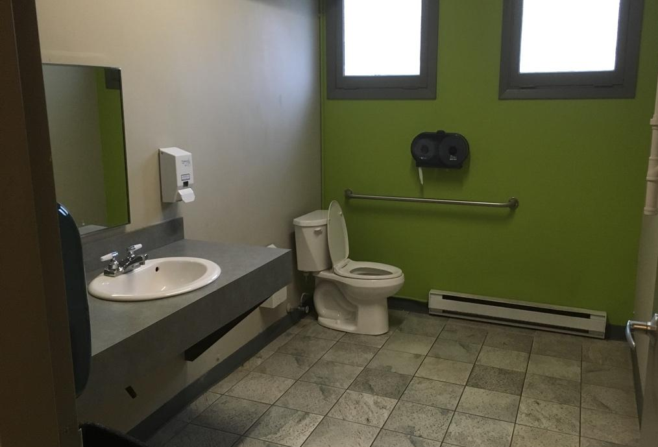

Entering the theatre
The theatre is through the doors at the end of the lobby. For OUTstages, UNO Fest, and most other shows, the doors to the theatre will open 30 minutes before the show starts. For non-Intrepid events, the theatre doors may open at the same time as the front doors. For the Fringe Festival, they’ll open 15 minutes before the show.
This is what the doors look like when closed.
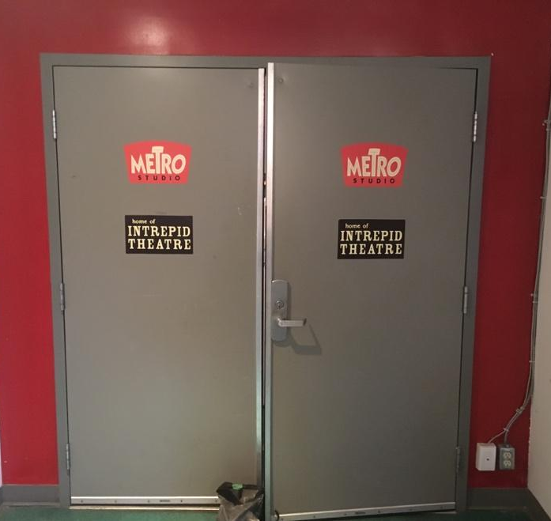
And this is what they look like open.
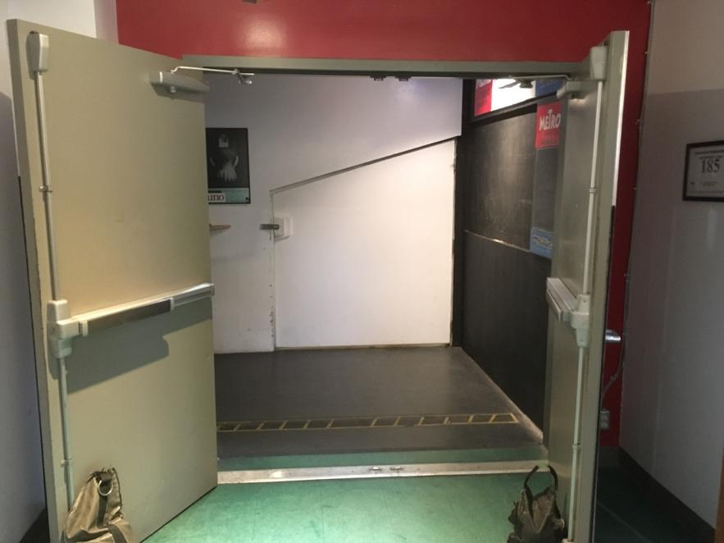

When you enter into the theatre, you’ll be in a corridor. To the left leads to the theatre. The corridor looks like this.
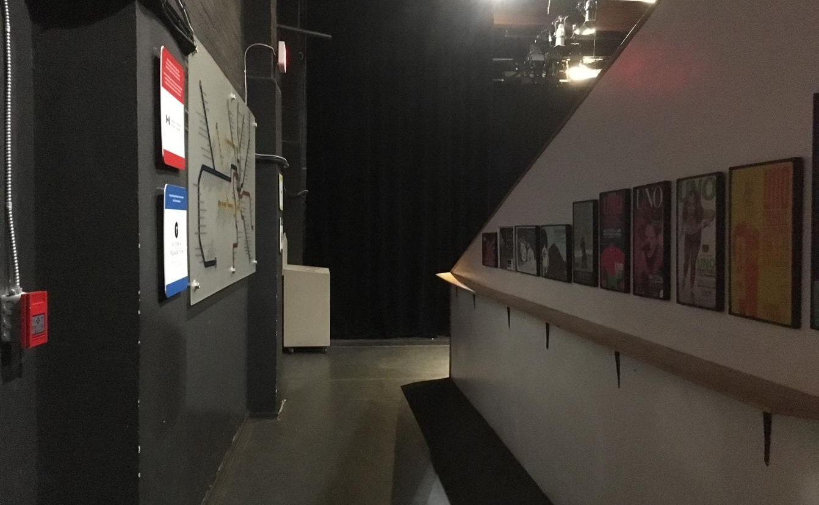

Concession

To the right is the bar/concession, which is open for all Intrepid festivals and presentations except Fringe, and for some non-Intrepid shows as well.
Some items that might be available for purchase are soda, water, beer, wine, cider, candy, and snacks.
You can take your drink to your seat.
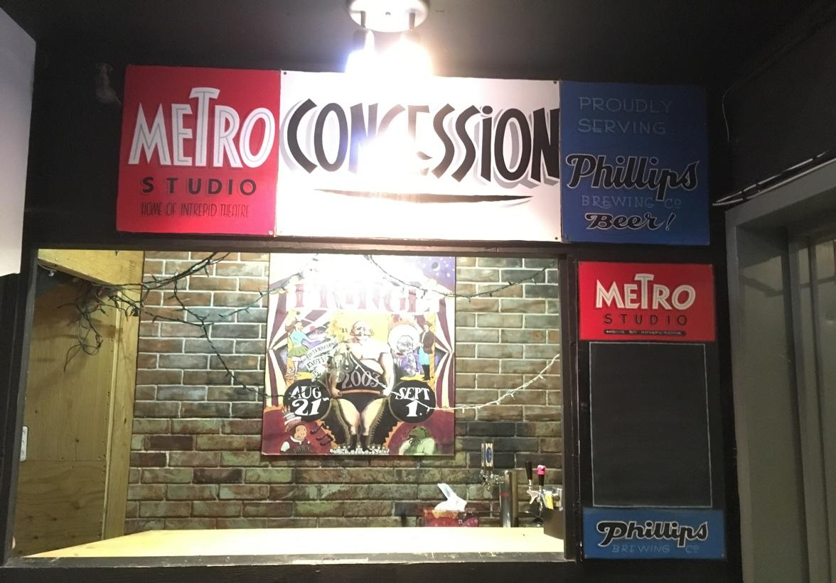

Inside the theatre
When you reach the end of the hall, the theatre is on the right. It looks like this.
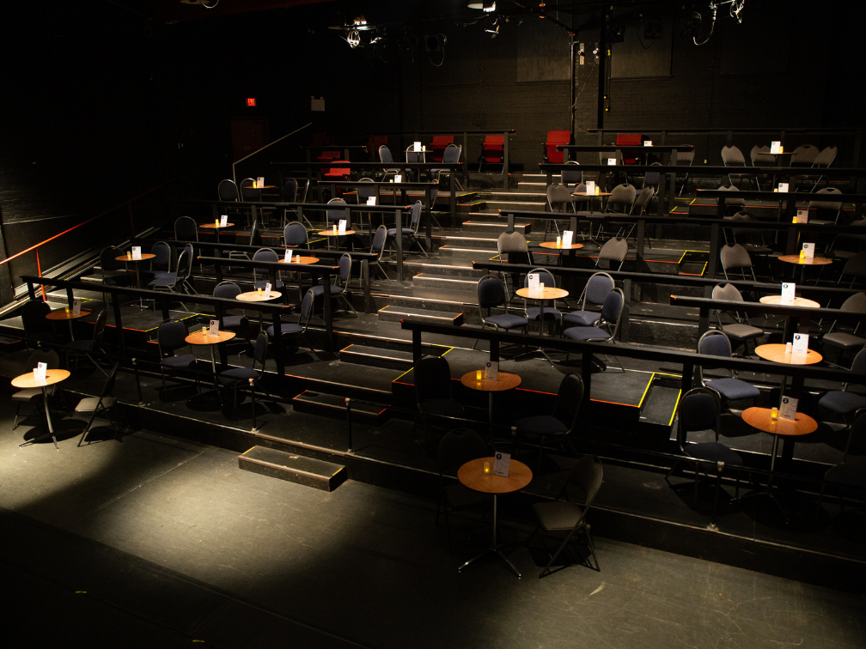
The stage is to the left and the audience seating area is to the right. There are seats for one person, tables of 2 and tables of 4. You will be assigned a table number and shown where it is by a volunteer usher. The Metro can fit 92 people in total. The red single seats fold down when you sit on them, and spring back up when you stand.
The front row is on ground level and is accessible for audience members using wheelchairs. You can request accessible seating when you book.
The rows of seats are tiered. There are three aisles with stairs: one on each side, and one in the centre. The aisle on the right if you are facing the audience area has a railing, the aisle on house left has a ledge you can lean on but not a railing, and the centre aisle doesn’t have any railing or support. The stairs are uneven in height and depth.

There is an emergency exit located on the opposite side of the theatre from where you entered, at the top of the stairs (the back corner of the theatre). Note, this picture is of the old seating, the chairs will not look like this, it’s just to show the exits!
If you need to leave the theatre during the performance, exit through the same doors you entered through. They look like this from inside.
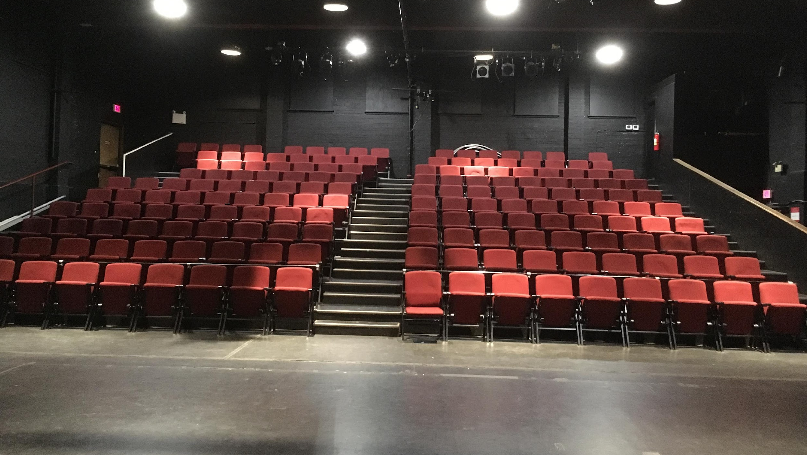

Emergency Exit
You
entered here

The stage faces the audience. It may have a set, props, or technical equipment on it. This is what the stage looks like from the centre of the audience.
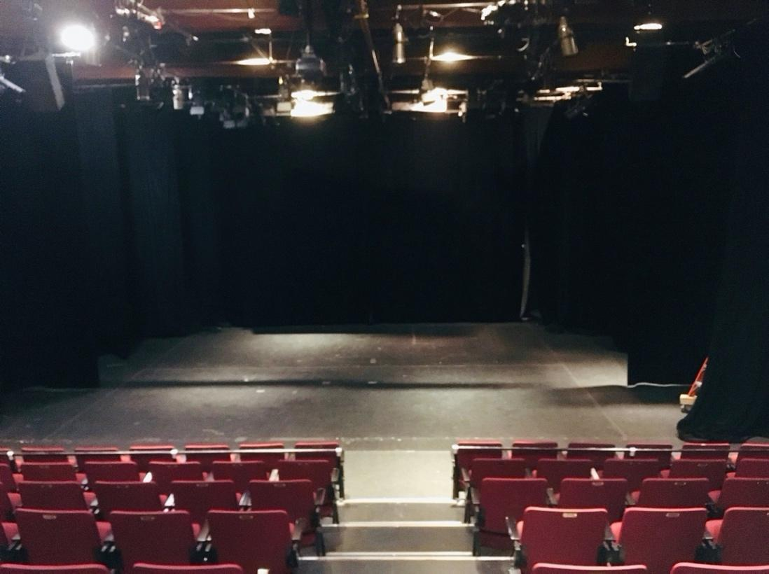
And this view is from the side on the ground level. These balloons are set pieces for a past show.
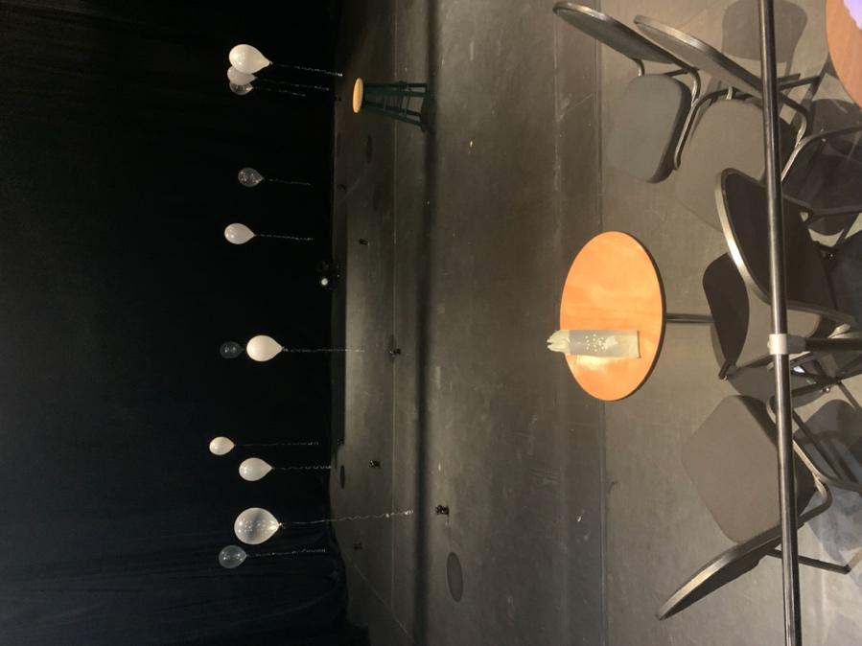

During the show

At the show start time, the Front-of-House manager, an Intrepid staff member, or someone from the show, will sometimes talk for a few minutes to welcome the audience and give some information about the show. They will mention effects that could be surprising or that audience members could be sensitive to, like haze or strobe lighting, and any content warnings about material in the show that could be triggering or upsetting.
Most Intrepid Theatre presentations and festival performances will start promptly on time. Some shows may allow latecomers, some may allow audiences to come and go throughout the show, and some may not admit latecomers at all—it varies from show to show. See individual show details at intrepidtheatre.com.

There might be an intermission in the middle of the show, which gives the performers and audience a break. It usually lasts about 15 minutes. During the intermission, you can get a drink or snack, use the washroom, or go outside.

During the show, the performers will usually be on the stage, but may be in the audience area too. There could be effects such as haze, bright lights, or loud music or sounds. The theatre may get very dark at times.
At the end of the show, people will clap, and might cheer, to show appreciation for the performers. If it is too loud, it’s okay to cover your ears. If you want to show appreciation without clapping, you can wave your hands in the air.

After the show
If there is an event after the show, like a reception or a discussion with the artist, it will be in the theatre, and there will usually be an announcement to tell you about it.
Artists sometimes have merchandise for sale on the stage or in the lobby.
When the show is over, you will exit the theatre to the lobby through the same doors you came in. The aisles might be busy while everyone is leaving their seats. From the lobby, exit through the main front doors (push to open), and you’ll be back on the corner of Quadra and Johnson Streets.
Because there are many companies and groups that have shows at the Metro Theatre, the procedures and rules will be different for every show, so we can’t tell you exactly what to expect. Some things that might be different, depending on what you’re here for, are:
?
- If there is a box office
- If you can buy tickets at the door
- What time the theatre opens
- If there is a concession or bar
- If the Front-of-House manager talks to the audience before the show
- If and when latecomers are admitted
- If you can exit the theatre and come back in during the show
- If there is an intermission
- How long the show is
- How many staff or volunteers are present
- If there are signs or an announcement to let you know about effects such as haze, strobe lighting, or loud music or sound effects.
However, each show will have someone present who will know the answers to these questions, so you can always ask before the show starts.

Accessibility Info
For information about accessibility measures at Intrepid Theatre festivals and presentations, such as relaxed performances, American Sign Language interpretation, and live audio description, visit our website intrepidtheatre.com.

We hope you enjoy your visit!
If you have any questions, or feedback about your experience at the Metro Studio Theatre or about this guide, please contact Sammie by emailing sammie@intrepidtheatre.com or calling Intrepid Theatre at 250-383-2663.

